

# **1st Programming Assignment: Corner Detection**

CSE 6239 (July 2020)

Report By:

**Name**: Md Mamun Hasan

**Roll**: 1907555

**Description:**

Corner detection executed for 8 images with different criteria is reported below with results.

**Image**: img1.png

**Kernel**: Gaussian

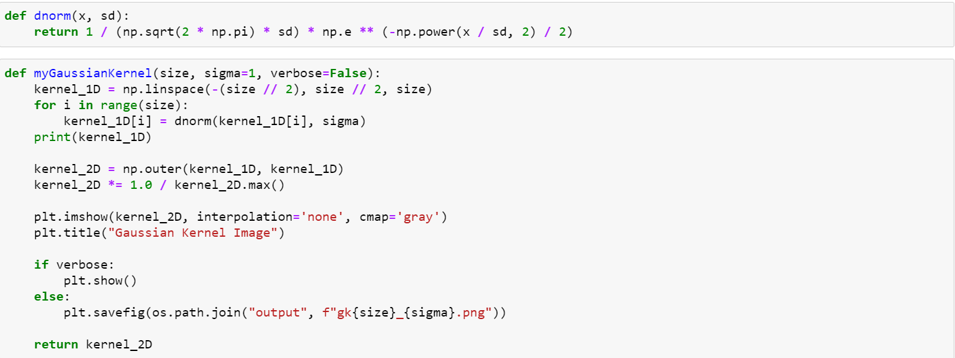

|  |  |  |  |  |
| --- | --- | --- | --- | --- |
|  | Size: 3  Sigma: 1 | Size: 5  Sigma: 2 | Size: 5  Sigma: 2  Scale: 0.75 | Size: 5  Sigma: 2  Scale: 1.25 |
| **Kernel** |  |  |  |  |
| **X Derivative** |  |  |  |  |
| **Y Derivative** |  |  |  |  |
| **Harris**  R Threshold = 10000.00 |  |  |  |  |
| **Kanade**  R Threshold = 100.00 |  |  |  |  |
| **Nobel**  R Threshold = 1.00 |  |  |  |  |

Bar chart for above **Gaussian** filter

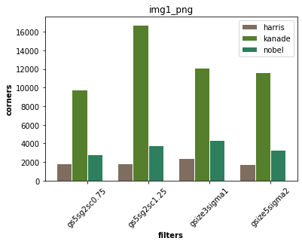

**Comments:**

1. Harris algorithm has worked well.
2. Kanade works very bad
3. Scale up detected more accurate corners
4. 15.5% corners are found common for 3 algorithms

**Kernel**: Box

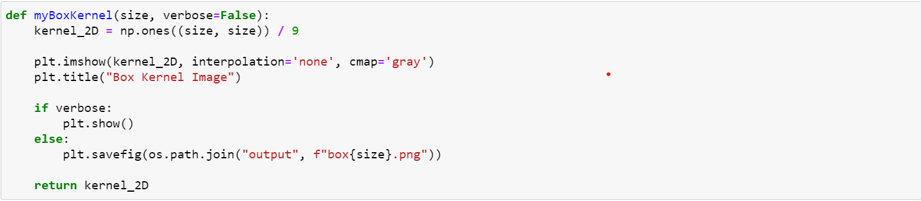

|  |  |  |  |
| --- | --- | --- | --- |
|  | Size: 3 | Size: 5 | Size: 5  Scale: 1.25 |
| **Kernel** |  |  |  |
| **X Derivative** |  |  |  |
| **Y Derivative** |  |  |  |
| **Harris** |  |  |  |
| **Kanade** |  |  |  |
| **Nobel** |  |  |  |

**Code from myImageFilter() conv by kernel:**

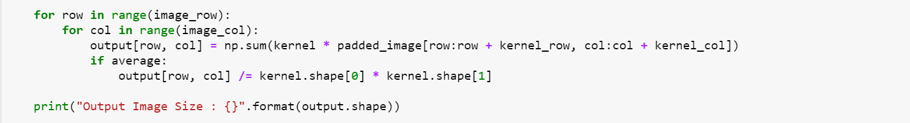

Bar chart for above **Gaussian + Box** filter

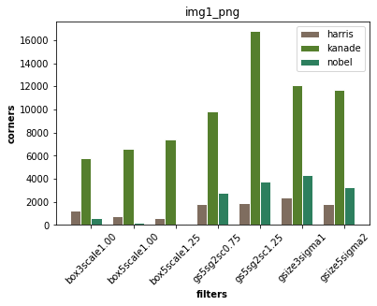

**Comments:**

1. Less corner detected in box filter
2. Again scaling up detect more corners

**Code for R calculation:**

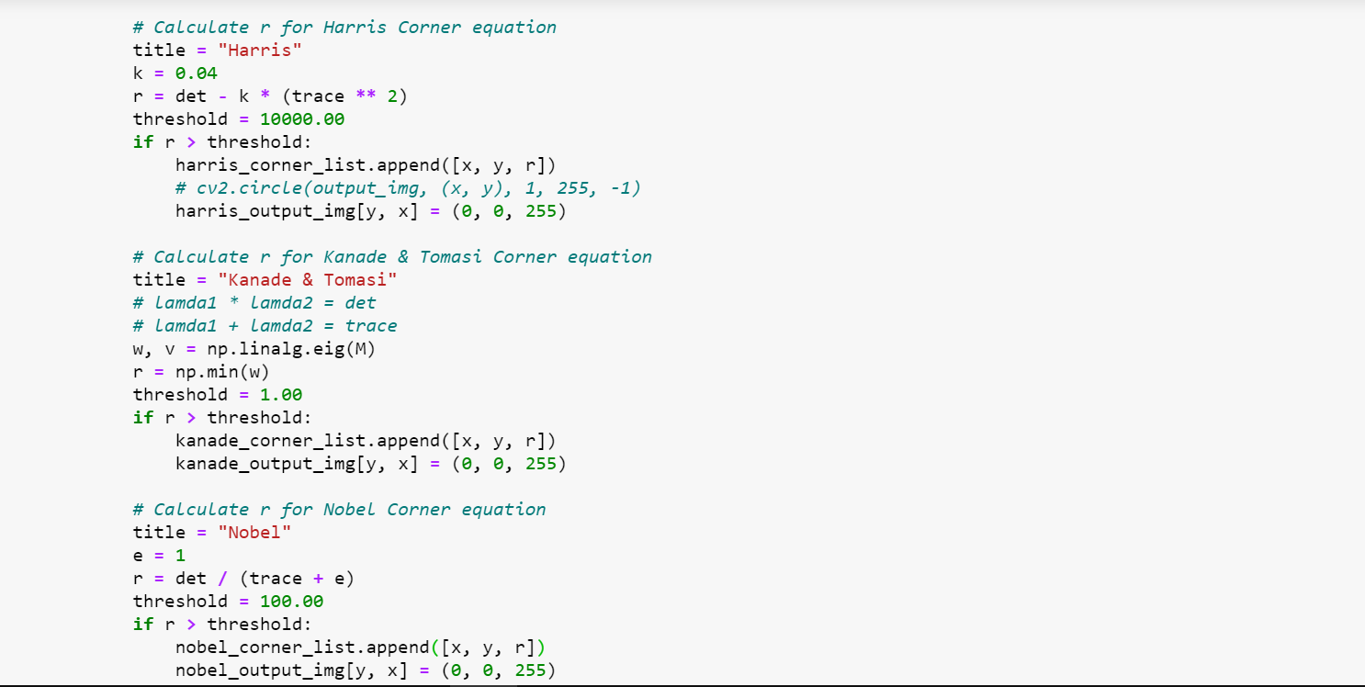

Similar process applied for all other provided images and For more programming reference please visit [here](https://github.com/mdmamunhasan/image-corner-detection/blob/main/corners.ipynb).

**Image:** img2.jpg

|  |  |  |  |
| --- | --- | --- | --- |
|  |  |  |  |
| **X Derivative** |  |  |  |
| **Y Derivative** |  |  |  |
| **Harris** |  |  |  |
| **Kanade** |  |  |  |
| **Nobel** |  |  |  |

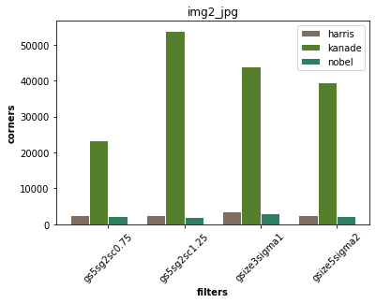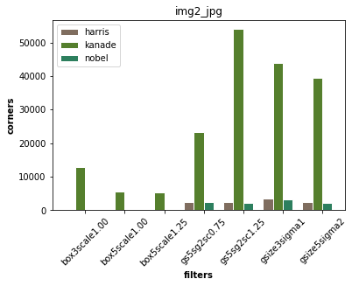

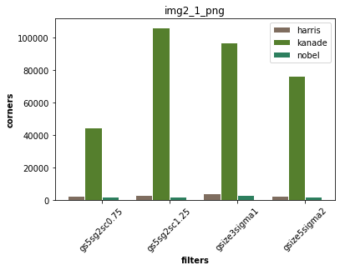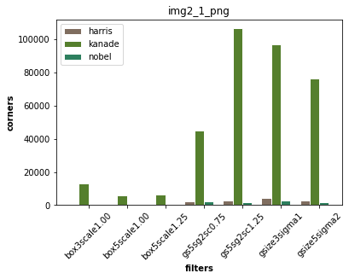

**Comments:**

1. Harris and Nobel algorithms do not perform well with the box kernel but work well with the gaussian kernel.
2. So much noise is found in the Kanade algorithm with the gaussian kernel. But with the box kernel Kanade algorithm works well.
3. Here 95% corners are common for kernel size difference

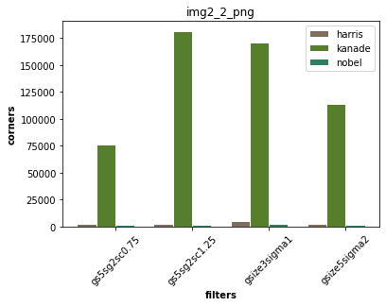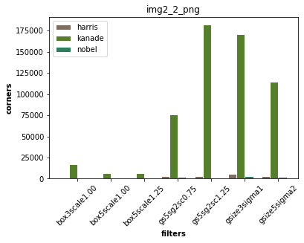

**Image:** img3.jpg

|  |  |  |  |  |
| --- | --- | --- | --- | --- |
|  |  |  | Scale: 1.25 |  |
| **X Derivative** |  |  |  |  |
| **Y Derivative** |  |  |  |  |
| **Harris** |  |  |  |  |
| **Kanade** |  |  |  |  |
| **Nobel** |  |  |  |  |

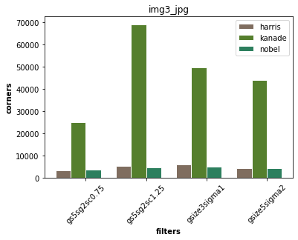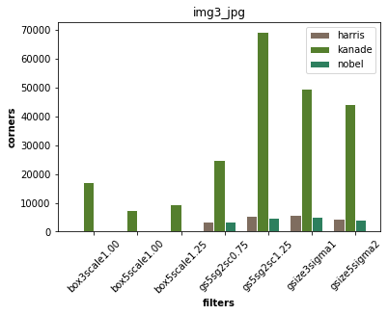

**Image**: img4.png

|  |  |  |  |
| --- | --- | --- | --- |
|  |  |  |  |
| **X Derivative** |  |  |  |
| **Y Derivative** |  |  |  |
| **Harris** |  |  |  |
| **Kanade** |  |  |  |
| **Nobel** |  |  |  |

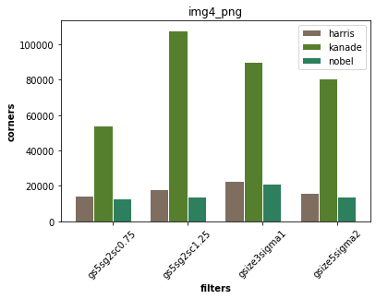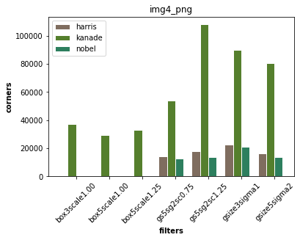

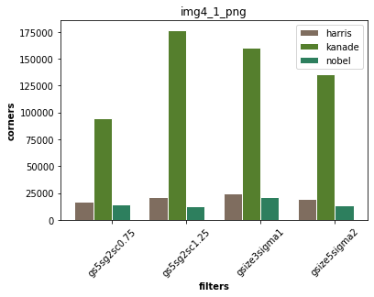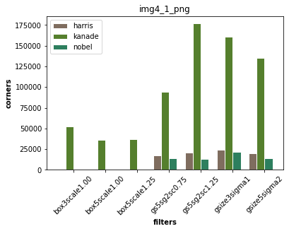

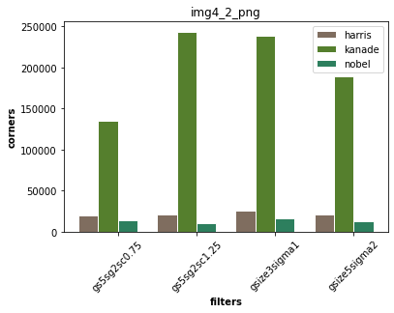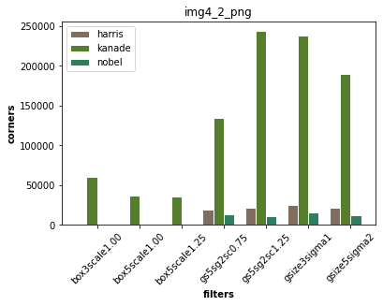

**Comments:**

1. No corners detected for Harris and Nobel algorithm with box filter.
2. Other results are almost the same as previous.